***How to Download & Install Selenium WebDriver in eclipse ide***

*Reference module:*

### Step 1 - Install Java(eclipse ide )on your computer

### Step 2 - Download the Selenium Java Client Driver

### Step 3 - Configure Eclipse IDE with WebDriver

1. Launch the "eclipse.exe" file inside the "eclipse" ,select for a workspace, just accept the default location.

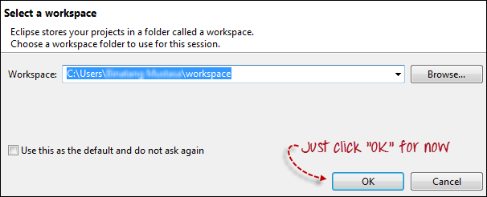

1. Create a new project through File > New > Java Project.

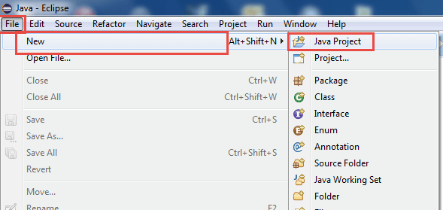

* A new pop-up window will open enter details as follow

1. Project Name
2. Click on Finish button

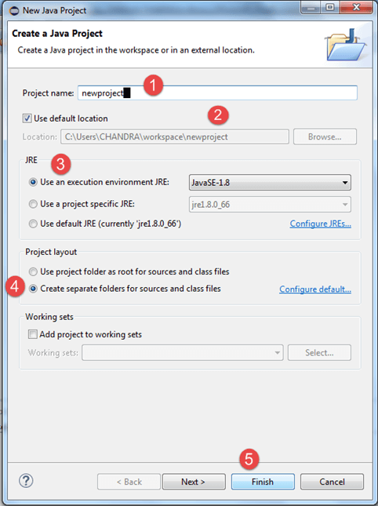

3. In this step,

1. Right-click on the newly created project and
2. Select New > Package and enter the package name.

[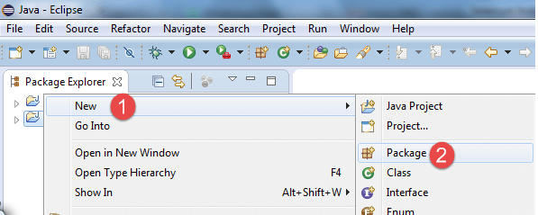](https://www.guru99.com/images/cassandra/021316_1152_SeleniumIns3.png)

A pop-up window will open to name the package,

1. Enter the name of the package
2. Click on Finish button

[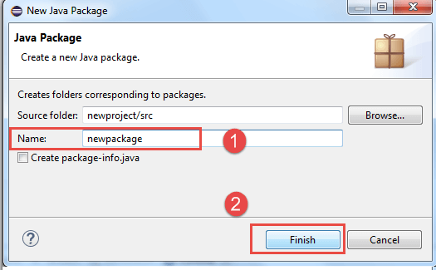](https://www.guru99.com/images/cassandra/021316_1152_SeleniumIns4.png)

4. Create a new Java class under newpackage by right-clicking on it and then selecting- New > Class, and then give the name of new class .

When you click on Class, a pop-up window will open, enter details as

1. Name of the class
2. Click on Finish button

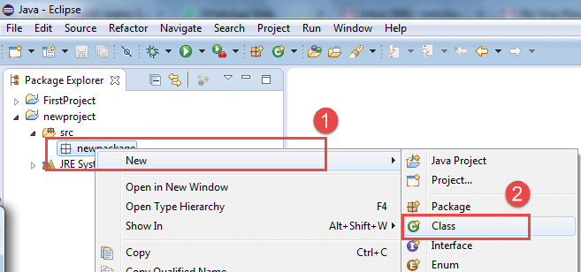

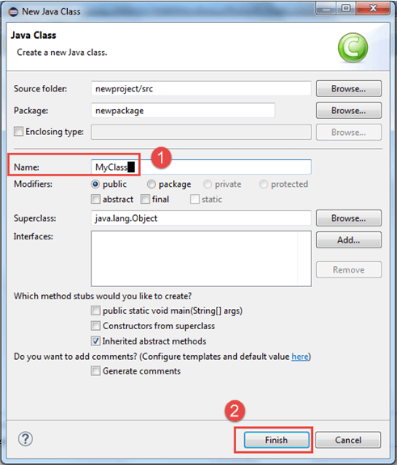

This is how it looks like after creating class.

\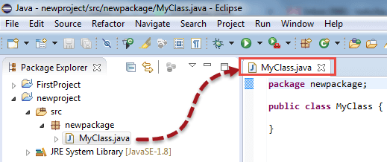

**Step4: In this step,**

1. Right-click on "newproject" and select **Properties**.
2. On the Properties dialog, click on "Java Build Path".

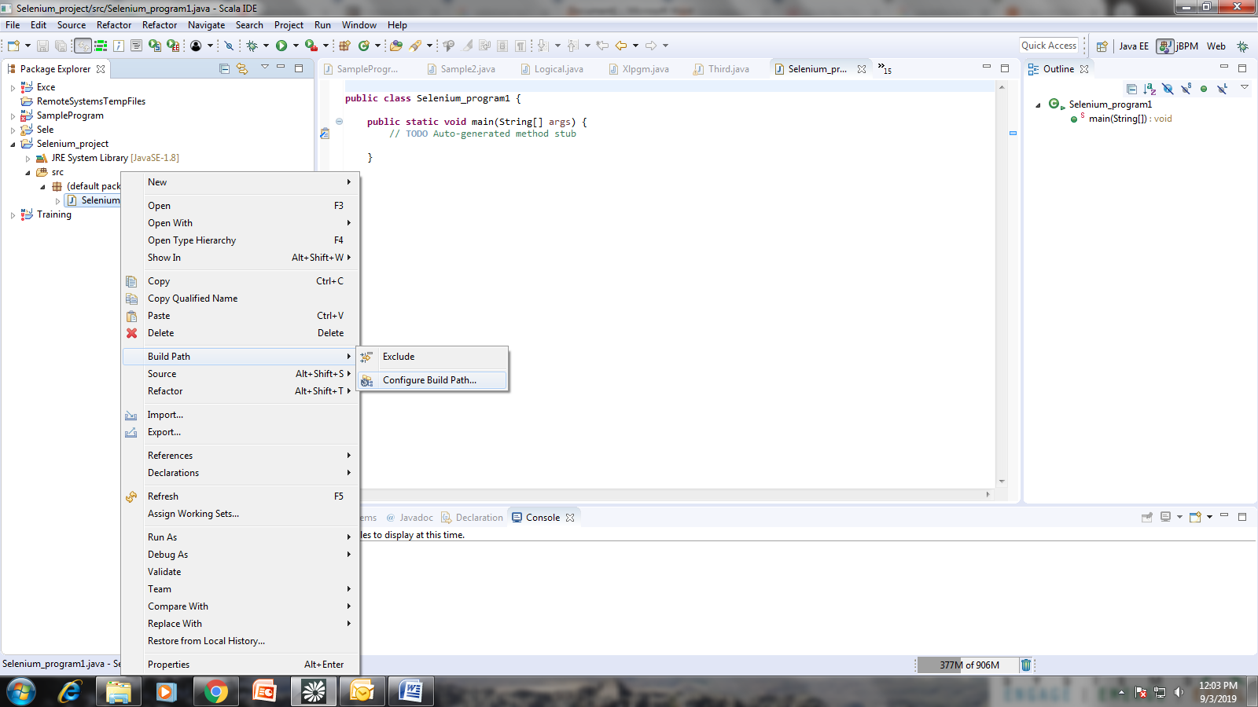

1. Click on the **Libraries** tab, and then
2. Click on "Add External JARs.."

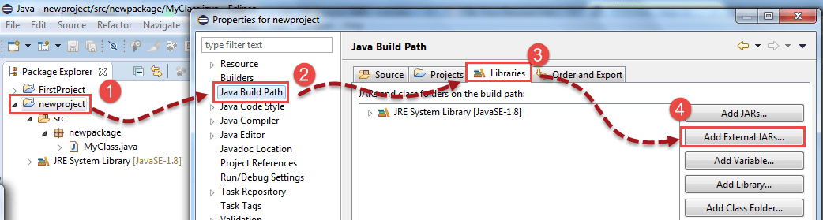

Step 5:When you click on "Add External JARs.." It will open a pop-up window. Select the JAR files you want to add.

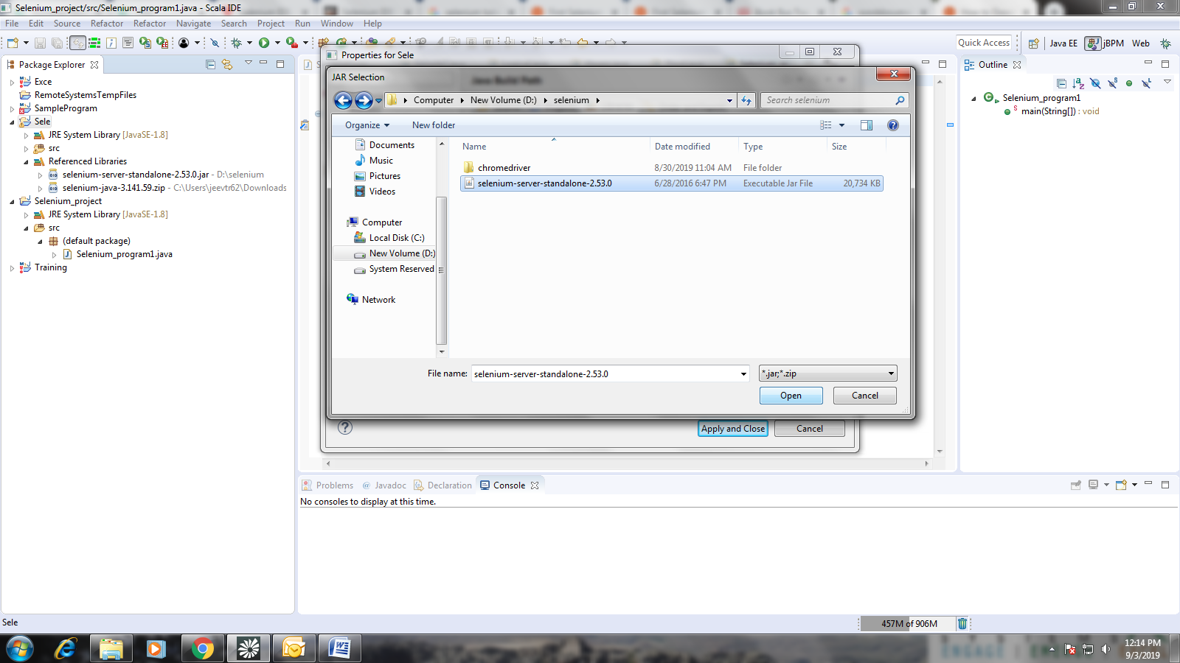

Step 6: Add all the JAR files inside and outside the "libs" folder. Your Properties dialog should now look similar to the image below.

[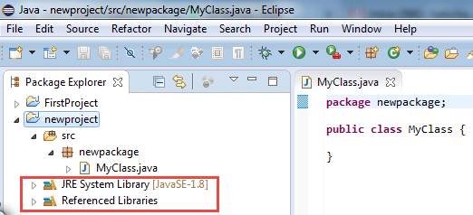](https://www.guru99.com/images/cassandra/021316_1152_SeleniumIns11.png)